

**CERTIFICATE**

This is to certify that the thesis entitled “Outage Probability and SER Analysis of Joint Relay and Antenna Selection in Full Duplex AF Relay Networks” submitted by Rashmi Ravichandran, School of Electronics Engineering, VIT University, for the award of the degree of *Bachelor of Technology in Communication Engineering*, is a record of bonafide work carried out by her under my supervision, as per the VIT code of academic and research ethics.

The contents of this report have not been submitted and will not be submitted either in part or in full, for the award of any other degree or diploma in this institute or any other institute or university. The thesis fulfills the requirements and regulations of the University and in my opinion meets the necessary standards for submission.

Place : Vellore

Date : **Signature of the Guide**

**The thesis is satisfactory / unsatisfactory**

**Internal Examiner External Examiner**

Approved by

Head of the Department [B.Tech ECE]

School of Electronics Engineering



**Executive Summary**

A joint relay and antenna selection method has been proposed which aims at improving the space diversity and error performance of full duplex (FD), amplify and forward (AF), relay network. The system consists of one source, one destination and *M* AF relays. The *M* relays are each equipped with one antenna which will act as a transmitter and one antenna which will act as a receiver. Based on the channel state information, the relay adaptively selects the best transmitter receiver configuration to improve the end-to-end performance between the source and the destination. In conventional FD systems, the transmitter and receiver antennas are fixed for each relay resulting in lesser space diversity. The end to end SINR for received signals has been derived, by considering the self-interference and noise factors into account. Closed form analytical expressions for outage probability and symbol error rate (SER) are derived. The performance of the proposed joint antenna and relay selection in AF network in comparison with the conventional optimal relay AF relay network significantly outperforms the conventional full duplex relay network.

|  |  |  |  |  |  |
| --- | --- | --- | --- | --- | --- |
| **CONTENTS** | | | | **Page No.** | |
|  | **Acknowledgement** | | | i | |
|  | **Executive Summary** | | | ii | |
|  | **Table of Contents** | | | Iii | |
|  | **List of Figures** | | | ix | |
|  | **List of Tables** | | | xiv | |
|  | **Abbreviations** | | | xvi | |
|  | **Symbols and Notations** | | | xix | |
| 1 | **INTRODUCTION** | | | 1 | |
|  | 1.1 | Objective | 1 | |
|  | 1.2 | Motivation | 1 | |
|  | 1.3 | Background | 4 | |
| 2 | **PROJECT DESCRIPTION AND GOALS** | | 10 | |
| 3 | **TECHNICAL SPECIFICATION** | | | 13 | |
| 4 | **DESIGN APPROACH AND DETAILS** | | | 14 | |
|  | 4.1 Design Approach  4.2 Codes and Standards  4.3 Constraints and Tradeoffs | | | 14  23  24 | |
| 5 | **SCHEDULE, TASKS AND MILESTONES** | | | 26 | |
| 6 | **PROJECT DEMONSTRATION** | | | .28 | |
| 7 | **SUMMARY** | | | 35 | |
| 8 | **REFERENCES** | | | 36 | |

**List of Figures**

|  |  |  |
| --- | --- | --- |
| **Figure No.** | **Title** | **Page No.** |
| 1 | Amplify and Forward Network System Model | 14 |
| 2 | Transmit Power - Outage probability comparison of ARS Scheme and ORS Scheme for M = 1 relays | 29 |
| 3 | Transmit Power - Outage Probability comparison for ARS Scheme and ORS Scheme for η = 0.05 | 30 |
| 4 | Self-Interference - Outage Probability comparison for ARS Scheme and ORS Scheme η = 0.05 | 31 |
| 5 | Transmission Rate - Outage Probability comparison of ARS Scheme and ORS Scheme for η = 0.05 | 32 |
| 6 | Transmit Power – SER analysis of ARS Scheme for M =1 relays | 33 |
| 7 | Transmit Power – SER analysis of ARS Scheme for η = 0.05 | 34 |

**List of Abbreviations**

|  |  |
| --- | --- |
| AF | Amplify and Forward |
| FD  HD  DF | Full Duplex  Half Duplex  Decode and Forward |
| EF | Estimate and Forward |
| S | Source |
| D  R  ARS  RF  MIMO  SINR  AWGN  SER  SNR  ORS  CDF  LTE  TDD  FDD | Destination  Relay  Joint Antenna Relay Selection  Radio Frequency  Multiple Input Multiple Output  Signal to Interference Plus Noise Ratio  Additive White Gaussian Noise  Symbol Error Rate  Signal to Noise Ratio  Optimal Relay Select  Cumulative Distributive Function  Long Term Evolution  Time Division Duplexing  Frequency Division Duplexing |

**Symbols and Notations**

|  |  |
| --- | --- |
| *M* | No. of Relays |
|  | ath chosen relay |
|  | Channel link between source and relay |
|  | Channel link at relay due to loop interference |
|  | Re-transmit signal from relay |
|  | Source signal |
|  | Power amplification factor |
|  | Additive white gaussian noise at relay |
|  | Signal received at the relay |
|  | Processing delay |
|  | Transmit power of the source |
|  | Additive white gaussian noise transmit power |
|  | Received signal at destination |
|  | Channel link between relay and destination |
|  | Additive white gaussian noise at destination |
|  | Source relay SNR |
|  | Relay destination SNR |
|  | Relay SNR |
|  | Source Relay SNR modelled as Exponential Random Variable with Expectation |
|  | Relay destination SNR modelled as Exponential Random Variable with Expectation |
|  | Relay SNR Modelled as Exponential Random Variable with Expectation |
|  | Channel distribution function for source relay channel link |
|  | Channel distribution function for relay destination channel link |
|  | Channel random variable with expectation |
|  | Relay random variable with expectation |
|  | Antenna selection procedure parameter |
|  | Ant1 forwards information to Ant2 |
|  | Ant2 forwards information to Ant1 |
|  | ARS selection parameter |
|  | CDF of end-to-end SINR |
|  | Power of received signal |
|  | Self-interference parameter |
|  | First order modified Bessel function |
|  | CDF |
|  | Outage Probability |
|  | CDF function |
|  | Modulation parameter |

1. **INTRODUCTION**
   1. OBJECTIVE

In this project, a method is proposed in “Outage Probability and SER Analysis of Joint Relay and Antenna Selection in Full Duplex AF Relay Networks” to better the throughput of wireless communication in cooperative networks. Self-interference is a vital factor which affects full duplex wireless communication. It causes signal attenuation in a communication channel and hampers communication over large distances. In an attempt to alleviate the effect of self-interference, the proposed system has been devised to increase space diversity between two communicating nodes and thereby eliminate the effect of self-interference. The system aims to achieve this by a reinforced method of joint antenna and relay selection. In this model based on channel state information, the appropriate relay is chosen. This results in self-interference suppression with an increase in angles of diversity.

* 1. MOTIVATION

Modern wireless communication is driven by full duplex systems which employ a wide variety of relaying techniques. These networks are said to “cooperatively” communicate with each other and achieve the required system capacity.

Before an understanding on these complex systems can be established, certain key concepts and ideas must be understood. Almost all of modern day communication needs to be carried out swiftly without signal attenuation. This can only be achieved through means of a full duplex system. A Full-Duplex (FD) wireless [communication system](https://en.wikipedia.org/wiki/Communication_system) is one which can achieve bi-directional communication between two parties which are connected to each other by means of antenna or radio link. The word "Duplex" is derived from "[duo](https://en.wiktionary.org/wiki/duo-)" which means "double", and "[plex](https://en.wiktionary.org/wiki/-plex" \o "wikt:-plex)" which means "structure" or "parts of”. Hence, the data transmission in a full duplex system occurs in two directions simultaneously. Let us consider a situation of point-to-point communication between two nodes of communication, namely A and B.

If “A” is considered to be the source and “B” is considered to be the destination, two channel links is established between A and B. Through one channel A can communicate with B and through another channel, B can communicate with A. This primary idea forms the basis of full duplex communication. It is important to note this communication occurs simultaneously, resulting in a greater transfer rate of signals which fuels modern day communication. The advantages of FD communication can be summarized as follows:

* Collisions do not occur between signals and hence, time is not wasted in having to retransmit frames.
* Second, full transmission can achieve maximum capacity in both directions because the send and receive functions defining communication in such systems are separate.
* Third, since there is only one transmitter and receiver pair on each node which is coded for and participates in communication, it does not need to wait for any other communication process to end in order to function.

However, despite the many noteworthy advantages that FD Systems may have, they still suffer from issues such as attenuation of communication signals and interference between channel links. This issue particularly becomes particularly noticeable when communication occurs over large distances. When signals are sent over a large distance, its channel composition changes from region to region. Fading of the signal strength occurs because signals are deflected and get lost due to collision with dust particles and edges of mountains and buildings [1]. However, these issues have been handled through means of signal processing and are not the primary focus of this project. The project focuses on another method used to handle fading issues – relaying.

A relay is a combination of multiple antennas which are placed between a source and a destination node. A relay usually comprises of a transmitter and a receiver antenna to re-transmit information between the source and the destination node. The relay node does not add any new information to the signal to be sent to the destination. It primarily receives the signal from the source, amplifies it and attempts to retrieve any corrupted information due to fading effects of the channel between the source and the destination and then re-transmits the signal to the destination. For this reason a relay is often called an “AF Relay” because it does the work of amplifying and forwarding signals while maintaining the original transmit power of the data. While our project focuses only on the Amplify and Forward type of relaying protocol, there are two other means in which a relaying between source and destination can be achieved. These other two methods are primarily:

* [Decode-and-Forward](http://ita.ucsd.edu/wiki/index.php?title=Decode_and_forward) (DF): The relay in this case is used for high security and sensitive functions only. It decodes and re-encodes the received signal which is then forwarded to the destination. The processing of the input signal at the relay is known as “making a hard decision” because the information which is sent by the relay does not include any extra information bits about the source-relay link. These extra bits are usually encoded to aid in error processing of the received information at the destination. When the modulation used in this protocol is decoded, it is also known as Detect-and-Forward as the processing of the relay also involves the major task of detecting the signal.
* [Estimate and Forward](http://ita.ucsd.edu/wiki/index.php?title=Estimate_and_forward) (EF) : This protocol is better known as Compress and Forward or/and Quantize and Forward. At the relay node, a mathematical transformation is applied to the received signal, which provides an estimate of the information content of the source signal. This estimate is also known as soft information, which is forwarded to the destination. This method of relaying is preferred in high outage probability fading channels

However, for this system design a simple AF Relay protocol has been chosen as it achieves the required performance that is desired.

Employing, FD and AF Relays in our proposed network design; majority of the problems faced in point to point communication have been solved. However, amongst the antennas present on the node of the AF Relay, there often occurs the problem of “Self-Interference”. This problem is solved by allowing the appropriate selection of Transmitter and Receiver antennas on the relay node based on the instantaneous channel state information. While antenna selection on a particular relay is existing technology which achieves considerable amount of space diversity, it suffers from residual interference and results in higher outage probability of the signal which can otherwise be eliminated. Achieving additional space diversity and allowing for more angles of freedom in the transmission of data between channel links, can be achieved by a MIMO system employing multiple relays and then selecting the relay with the best transmitter-receiver configuration. This is the aim and breakthrough of the proposed system.

The proposed system comprising of a source, destination and a series of relay nodes can also be called, a “Cooperative Network”, as it forms the smallest possible unit of a Cooperative Network by definition. A network is said to be Cooperative network when when a direct communication between a source (S) and a destination (D) is improved with help provided by a neighboring strategically configured node. This neighboring node is referred to as a relay (R). The Relay in our network runs on an AF Relay Protocol and is responsible for re-transmitting the data received from the source to the destination.

A cooperative AF Relay network has been taken and improved by means of using a joint antenna and relay selection (ARS) method in this proposed system model. This system will be further explored in the upcoming chapters.

* 1. BACKGROUND

1.3.1POTENTIAL OF FULL DUPLEX COMMUNICATION

A majority of modern day communication is presently dependent on half-duplex mode in which information can only be sent in one direction in a given time frame. In other words, in a single channel, the system can other transmit or receive a signal but it cannot do both simultaneously. Full-Duplex communication in only in recently making an entry in full duplex communication as it has shown to improve the capacity of the system by allowing communication between the transmitter and the receiver simultaneously. Wireless signals tend to attenuate over a large distance and hence, the need for full duplex communication became imperative [2]. The authors have attempted to achieve full duplex communication in a radio and have shown it advantages and improved performance through a comparative study with half duplex networks. This study describes the design of a practical single channel wireless full-duplex system. The throughput gain that has been achieved for this wireless channel is below 8%of the desired value of an ideal full-duplex system. Thus there is feasibility of designing a full duplex communication system. However, there lie restrictions in implementing wireless full-duplex systems. Such systems require the design of noise cancellation circuits for a wider band which covers a large number of frequencies and the design and implementation of an effective interference cancellation algorithm. Antenna cancellation, RF interference cancellation and digital interference cancellation have been used together to control self-interference and to bring it to within a few dB of the noise floor. There exists a loss of a few dB in SINR, which can lead to unsatisfactory performance for MIMO system. SNR/SINR based schemes would have to take into account the loss in SINR due to self-interference. Wireless channels are variable in nature due to the fading effects of the channel. Even at the short distance between the transmitter and receiver antennas, the channel gain varies drastically with limited operation time. The noise cancellation circuit is complicated and is highly specific in configuration. It requires the manual setting of amplitude and phase for effective cancellation of interference. In order to improve the performance of these full duplex systems, relaying has been introduced. Relays serve to eliminate interference issues and improve the channel gain by stabilizing it. Another method used to address the self-interference issue has been explored in [3]. A joint relay and Tx/Rx antenna mode selection scheme with adaptive power allocation is introduced to combat the performance floor in high SNR region. Each relay is allowed to calculate its optimal Tx and Rx antenna configuration and the optimal power allocation jointly based on the instantaneous channel conditions. Only the optimal relay in multiple relay system is active to forward the information from the source to the destination. Considering the beamforming issues of MIMO systems which must be addressed together with inter relay interference and self-interference, a study is carried out in [4]. A joint Relay Selection and Beamforming Design schemes is considered, taking Inter Relay Interference into consideration by using multiple antennas at the relays. To maximize average end-to-end rate, a weighted sum-rate maximization strategy is concocted assuming that adaptive rate transmission is employed in both the source to relay and relay to destination links. In this situation, several Beamforming Scheme cancel or suppress Inter Relay Interference in order to maximize the weighted sum-rate. Additionally, signal processing has been used to solve the self-interference problem [5]. In this model, the outage performance in a full-duplex relay (FDR) channel adopts an amplify-and-forward protocol. A new closed-form expression is derived for the outage probability that captures the joint effect of residual self-interference and direct link. In another effort [6], a two-way full-duplex amplify-forward relay cooperative communication system is considered, of which all transceiver nodes operate in full duplex mode. It is considered that the self-interference (SI) introduced by the Co-time Co-frequency transceiver is closely related to the local transmitting power. The average power of residual self-interference is taken as the transmitting power multiplied by one coefficient representing the SI cancelation capability quantitatively. The exact expressions of the outage probabilities for the forward and backward links are derived which suppress self-interference.

1.3.2 RELAYING IN FULL DUPLEX NETWORKS

In full duplex communication, fading of the information signal from the source often occurs due to multipath propagation. In order to eliminate this multipath propagation the use of relays has been added to full duplex systems, between the source and the destination node.[7] Space diversity methods are attractive and preferred because they can be easily combined with other forms of achieving diversity in existing communication systems like time and frequency diversity and still offer noteworthy performance gain which enhances the overall performance of the system. Conventional methods of achieving space diversity relied on dispatching physical array antennas in the channel to improve propagation. In the work described in [8], a space diversity algorithm is built upon the conventional relay network model and it eradicates the problem of creating and utilizing space diversity through the means of using a network of distributed antennas within multiple terminals, each with its own information to transmit. This form of diversity is known as space diversity or cooperative diversity because the terminals share the antennas and resources to create a virtual array and manage to transmit information through means of distributed transmission and signal processing methods. These cooperative networks have been known to solve the problem of attenuation of signals and outage probability significantly.[9] They have been effective in improving information at the edge of the cellular network where hexagonal cells of communication overlap. Their advantages also increase to hotspot areas where there has been a significant decrease in the outage probability value measured.

1.3.3 SELF-INTERFERENCE CANCELLATION METHOD

However, despite the efficient usage of channel bandwidth and space diversity in there lay AF systems developed, there is a significant amount of self-interference leakage between the input and output antennas of the relay array. This causes information which should be sent from the output antenna to get received by the input of the same relay thereby causing loop effects which significantly reduce system performance. In order to combat the issue faced in this proposed system, a method of decreasing loop interference have been suggested through means of introducing some techniques such as:

* Antenna Separation: This is to ensure no signals from the transmitter of the relay can be received at the relays’ receiver due to the presence of considerable distance between then that nullifies the possibility of loop interference occurring. [10]
* Directional Antennas: These antennas involve a change in the antenna design. Antennas are designed to have a direction of propagation such that signals travel only in the intended direction of propagation and do not stray away from their path. These antennas resemble a geometric funnel fitted over the head of the transmitter module of the signal such that the signal gets amplified as it strikes the sides of the antenna and propagates in the direction of the ultimate destination.[11]
* Time Domain Cancellation of Interference: In this technique signal processing methods are used to prevent interference between the time-blocks of information which is to be forwarded between the source and the destination. This interference occurs when there is a discrepancy between the cyclic prefix length and the length of the time block. This interference is cancelled by means of a Alamouti Coded Algorithm.[12]

However, as these methods might succeed in eliminating a great part of the interference affecting the relay node, there still exists residual self-interference. This exists due to improper physical isolation of the system and improper spacing between antennas. Another reason for its existence is the imperfect cancellation algorithm which does not cause effective cancellation of loop interference.[13]

In an attempt to better eradicate this residual self-interference, an attempt is made to model this noise in the receiver of the relay node as additive white Gaussian noise (AWGN). This additional noise is removed from the receiver through means of using signal processing techniques and this process is mathematically solved.

1.3.4 ANTENNA SELECTION SCHEMES

A parallel approach to avoid self-interference has been explored in [14]. In this method, multiple input multiple output (MIMO) network of relays are considered. Multiple relays each equipped with antennas capable of carrying out transmitting and receiving data. While there is only one source and destination in these networks, there exist multiple relays in order to allow for a greater coverage of space diversity and select the best relay of the multiple relays which can offer the most optimized communication between the source and the destination. This results in a lowering of outage probability and allows for lower attenuation of communication signals. Self-interference is also tested against the system which performs well and achieves better results in comparison to its conventional counterparts.

In expansion to the research work done in [14], parallel work has also been accomplished which allows for the same throughput but with means of using both full duplex and half duplex relaying. Such a system is considered to be “Hybrid Relaying”. In this situation the MIMO relay network chooses which of the relay to activate for communication between the source and the destination based on the channel state information at that given instant. On the basis of this information, a relay is selected which can best re-transmit the information from the source to the destination. However, in case of a deep fading channel, the relay switched between FD and HD relaying dynamically depending on instantaneous channel state information which it is periodically collecting. In case the channel goes into deep fading, the relay switches to HD mode and controls the flow of information to allow only transmission or reception to occur in a single time frame. If the channel is not attached by fading factors after the choosing of relay, then FD communication resumes.

While this method allows for a better, more reliable transmission method between the source and the destination, it still suffers from interference due to deep fading. This arises because after the deployment of the relay, the transmitter and receiver antenna don’t change. Hence, it may be possible that, while the channel link between the source and the relay may be suitable for communication and the channel link between the relay and the destination may fall into deep fading. In this scenario, this proposed system fails and the need for the design and analysis of a new system arises.

1. **PROJECT DESCRIPTION AND GOALS**

Joint relay and antenna selection method has been proposed in this project which aims at improving the space diversity and error performance of full duplex (FD), amplify and forward (AF), relay networks. The system comprises of one source, one destination and M AF relays. The M relays are each equipped with one antenna which will act as a transmitter and one antenna which will act as a receiver. Depending on instantaneous channel state information each relay, chooses an antenna will act as Transmitter and Receiver respectively. The relay with possesses the best Tx/Rx configuration to perform end-to-end communication between the source and the destination is chosen. Related to the field of wireless communication, the project provides a thorough study of joint antenna and relay selection and its performance in a realistic fading channel through the means of two parameters – Outage Probability and Average Symbol Error Rate (SER).

Conventional FD systems, suffered from self-interference between the antenna nodes of the relay. This self-interference was responsible for undesirable noise and attenuation of signals which affected communication. As a result, the throughput of the system suffered, resulting in high outage probability and high SER. Eradicating interference is the primary aim of the proposed system design. Self-interference is eradicated by achieving extra space diversity through the means of the proposed joint antenna and relay selection system. An analysis of this proposed system has been implemented on MATLAB® software by varying different parameters to study the Outage Probability and SER Performance.

In order to carry out an effective analysis of the proposed system we consider a full duplex communication network. This network comprises of AF Relay nodes to aid in data transmission. The components of the system are as follows:

* One Source Node
* One Destination Node
* Multiple AF relay nodes

Each of the AF relay nodes are equipped with two antennas. One antenna is used for transmitting the signal and the other antenna is used for receiving the signal. In our proposed model we consider a joint antenna and relay selection scheme. In this proposed method, the AF Relay along with its transmitter receiver configuration is chosen and is used for communication between the source and the destination. The antenna and relay selection is made on the basis of the channel state information, instantaneously. During the transmission, only the relay with possesses the required configuration of transmitter and receiver remains active. The other relays which are a part of the network do not function.

Unlike the conventional system, the transmitter and receiver is not fixed of the relay node. The relay is at liberty to adaptively choose which of its two antennas act as receiver and transmitter based on channel state information. This selection follows the same procedure as indicated in [15].

This procedure of selection of the optimal relay and antenna configuration can be explained as follows:

* Each of the *M* relays select which antenna will act as transmitter and which antenna will act as receiver according to channel state information
* Out of the *M* relays, based on which relay provides best end-to-end communication between the source and the destination, a relay is chosen to act as the relay for the transmission.
* While this relay is in operation and is transmitting information between the source and the destination, the other relays are not active.

This selection method is meant to provide an extra degree of freedom in selecting the optimal relay for transmission of information. It also assures increased space diversity between the source and the destination node through means of a joint antenna and selection process.

However, despite the merits of the system, it is considered that stray loop interference exists between the relay nodes. In order to account for realistic system model where interference is not ignored, the system considers interference in the form of Rayleigh Fading. This Rayleigh fading channel is applied to the transmitter and receiver of the FD relay node. The loop interference is considered to be constant in the channel links. This is held true even in the case of the relay configuration of transmitter and receiver. The loop interference value is considered to be an ever present value which is not eradicated.

On the basis of the above mentioned parameters and the given system constraints, the outage probability analysis and the SER analysis of the system is to be carried out. The mathematical derivation and the detailed mathematical description of the system can be found in subsequent paragraphs along with the results of the Outage probability and SER analysis.

1. **TECHNICAL SPECIFICATIONS**

For the analysis of this project, MATLAB® software was used.   
MATLAB (matrix laboratory) is a multi-paradigm numerical computing environment and fourth-generation programming language. Bessel function, complex calculations, plotting of graphs were developed and implemented on MATLAB®. Indicated below is the various system requirements necessary to run MATLAB® and realize the project.

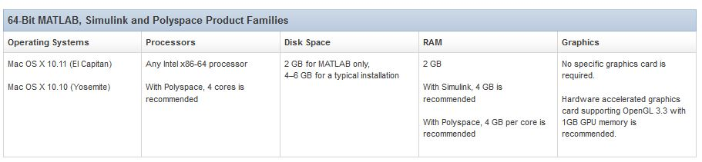

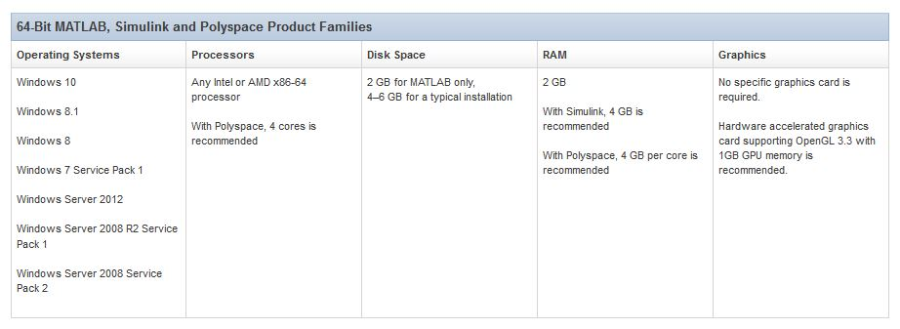

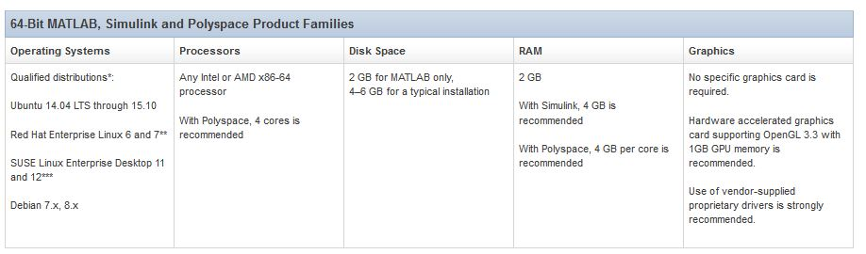

1. **DESIGN APPROACH AND DETAILS**

4.1 DESIGN APPROACH

4.1.1 SYSTEM MODEL

In this project a multiple relay system is considered which consists of a source node (*S*), a destination node (*D*) and *M* AF relay nodes as shown in the figure below.

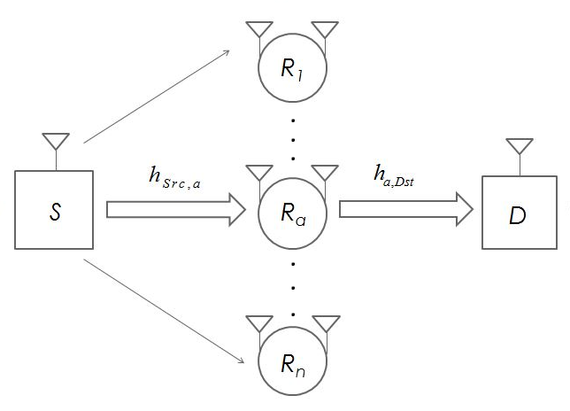

Fig 1. Amplify and Forward Relay Network System Model

It is assumed that there is no direct channel link between the source and the destination nodes. This is assumed because due to the limitations on transmission power which exist in modern day communication systems. Secondly, in order to consider a realistic evaluation of the system shadowing issues are considered leading to the necessity of a relay.

Thus, a relay is needed to send or re-transmit or relay information between the source and the destination. In this system, full duplex communication is implemented which demands that communication occurs bi-directionally in a given time frame. Also, this bi-directional communication must occur in the 4 channels links present, i.e between the source and the relay, the relay and the destination, the destination and the relay and the relay and the source. Due to this requirement, the same time-frequency block of information is used for transmission by the source and the relay node. The relay operates in FD mode to transmit information, with one of its antennas acting as transmitter and the other antenna acting as receiver. In this joint antenna selection and relay selection method (ARS), only the relay with possesses optimal transmitter-receiver configuration is activated out of M relays to forward the information to the destination from the relay. This transmitter-receiver configuration of each and every single relay is determined based on an instantaneous assessment of the channel SNR between the various antennas nodes involved in communication. Every relay performs this operation and a single relay is used for the end-to-end communication while the other relays do not take part in the communication process and are rendered inactive for the current communication.

In order to better represent the system and carry out a through mathematical analysis on the proposed system design, let us consider the system model as represented in Fig 2.

Considering that the ‘*a*th’ relay is selected out of the **relaysaccording to the method described above, to forward signals between the source and destination, the signal received at can be expressed as

 (1)

Where,denotes the channel link between source node and relay node anddenotes the loop interference existing between the transmitter and receiver antennas of the relay node.  And denote the *n*th transmitted signal from the source and relay transmit node respectively. Transmission power is provided for the transmission of data at both source and relay nodes. Also, is the AWGN with power of.

The relay first receives the signal from the source and then uses AF protocol to relay the signal to the destination. The signal which is retransmitted from the FD relay can be denoted as

 (2)

Where, power amplification factor is expressed as  and the processing delay is expressed as. Transmission power constrains govern cellular communication and  ensures that the following power constraint is satisfied by the power of the average signal

 (3)

Hence, from this equation, can be obtained as:

 (4)

At the destination, the received signal can be written as

 (5)

Where, denotes the channel between relay and destination and  refers to the AWGN noise with power allocation variance.

SINR for end-to-end system can be expressed as:

 (6)

On substituting, amplification factor in equation (6) we obtain

 (7)

Where, 

the channel links are all considered to be Rayleigh Fading Channels. This is considered so because each link remains constant during its respective transmission slot and does not change. Different links may undergo changes across different time slots but this change occurs independently for each.

Hence, SNR for the channels,,  and  can be expressed as exponential random variables with expectation, , andwhere, it is assumed the links between the networks are independently and identically distributed, which allows for the same assumption to be applied between the communication nodes of a network i.e. source/destination and relay.

This distribution can be expressed as

 (8)

Loop Interference channel links also follow a similar distribution which can be expressed as:

 (9)

4.1.2 JOINT ANTENNA AND RELAY SELECTION

A method used to select antenna and relay from M full-duplex relays is described in mathematical terms. It has already been assumed in Section III that each relay node is to contain two antennas. In order to perform full duplex communication, one of these antennas is to receive a signal from the source node and the other antenna is to forward the signal to the destination node at the same time. In previous work, the receive and transmit antenna is fixed for a single relay even when the channel links between the source, destination and relay suffer from deep fading. In order to improve system performance, the transmitter and receiver antenna for each relay has been adaptively selected. This procedure can be expressed as

 (10)

Where, and  represent the two antennas of the *a*th AF FD relay. is the end-to-end SINR of the transmission system when of the relay receives the signal from the source node and transmits it to  which acts as the transmitter to the destination node. Likewise is the SINR when  acts as a receiver at the relay node and forwards information to  for it to re-transmit to the destination.

Only the optimal relay with the optimal transmitter receiver configuration is chosen to carry out communication between the source and destination. Hence, the final representation of ARS method can be written as

 (11)

Where, 

4.1.3 OUTAGE PROBABILITY

A outage probability analysis is carried out for the ARS method. The performance of the FD relay system is analyzed in terms of Outage Probability.

The antenna selection method described in (10) states that there are two possible configurations in which antennas can be used. The SINR of the received signal can be described as follows according to the permutation theorem

 (12)

Rewriting the equation suitably, the end-to-end SINR as described in (7) can be written as:

 (13)

Where, is the SNR that exists instantaneously between source and nodes of the *a*th relay. is the SNR that exists instantaneously between source and node of the *a*th relay.is taken to simplify the equation further.

 (14)

Distribution of is derived from the expression given in [12]. It can be denoted as:

 (15)

Where 

For independent identical distribution case scenario, and is considered. The links between the source/destination and relay channels is considered to be independent. Considering relaying from, CDF of the end-to-end SINR of the *a*th relay node is:

 (16)

Where, integral of the CDF cannot be obtained as a closed form solution. The exponent is responsible for deciding the value of the integral. Hence, the variance of the following fraction is ignored and approximated as

 (17)

With this simplification and formula obtained from [12, eq. (3.324.1)], (16) can be written as

 (18)

The received SINR for is calculated in the same way in order to maintain symmetry.

From (7) and (10), (12) can be denoted as





 (19)

An approximation is made similar to (17). The fraction is simplified to a constant value 1/(1+ηa,1*x*+ ηa,2*x*). Hence, two independent integrals are formed. On solving mathematical equations in (18),

 (20)

Putting (17) and (19) in (12), the final CDF expression is obtained.

(21)

Where,

 (22)

From, the equation and from the relay selection method, outage probability is derived on the basic principle that: The optimal relay is chosen from a multiple relay network because it can achieve maximum SINR for end-to-end communication between the source and destination nodes. The outage probability of this ARS selection procedure of *M* relay networks is:

 (23)

The CDF function defining Outage Probability in (22) can be expanded as follows

 (24)

An approximation is taken in the equation instead of. The Taylor Series expansion for = 0 is

 (25)

The approximation is taken as

 (26)

Where,



The first three values of are, and . In our analysis if SER we use only the first two terms in the below algorithm.

 (27)

This approximation holds accurate when the value is close to 0. The quickly decreasing value of Q function results in an effect on high SNR part of the integral. This is omitted.

On substituting (26) into into integral according to formula [16, eq. (3.381.11)], average SER expression can be obtained as shown below.

 (28)

Where,

 (29)

Where,



4.2 CODES AND STANDARDS

* MATLAB: Outage Probability and SER simulation is evaluated and results are obtained through the software. The use of MATLAB is as follows:

1. To carry out tedious calculations such as Bessel Function and H matrix calculation which aid in the obtaining of above mentioned parameters.
2. To allow for the computation of conventional FD values which will allow for a comparison study between Joint Antenna and Relay Selection Method and the Convention FD Method of Communication

* LTE and LTE Advanced (DCS, IMT-E): The performance and throughput of these standards are kept as a standard to achieve with the incorporation of TDD and FDD in the proposed communication system design. This is to ensure that, the current proposed system may be incorporated with the existing communication setup used around the world.
  1. CONSTRAINTS, ALTERNATES AND TRADEOFFS

The following can be summed as the design constraints of the system.

* Self-Loop-Interference: This exists within the FD Relay Nodes and does not allow for complete eradication of Interference from the system. This restricts the diversity order that can truly be achieved.
* Performance Floor at High SNR : On increasing SNR values, the performance of the system cannot be analyzed and further mathematical analysis is required to derive Asymptotic Analysis of the same equations with appropriate approximation to the CDF.
* High Speed Connection Switches: The relay node needs to include a flexible connection switches between the antennas and the RF chains between Source and Destination nodes. This is to ensure that it can flexibly connect or disconnect the switches between the two antennas and two RF chains. Sometimes, this may cause a limitation to the system productivity if low speed switches are provided, as they defeat the purpose of “instantaneous channel condition analysis”.

The tradeoffs of the system are as follows:

* Diversity Multiplexing: It is required of the system to achieve maximum achievable reliability (space diversity) for a given rate of increase of transmission rate with increasing signal-to-noise ratio (SNR). Joint Antenna and Relay select only achieves the maximum space diversity gain point for a particular transmission rate and not multiple intermediate transmission rates which is optimally required of a system. It is also, not optimally designed for the corner points of the system. Despite this issue which can be solved in case of Compress and Forward Strategy of transmission for achieving all points of the optimal space diversity, Joint Relay and Antenna Selection is used because it achieves the required space diversity with the minimum number of active antennas.
* Diversity versus SI: By varying the number of transmit antennas and receive antennas, by employing a larger number of active relays in the system, a tradeoff between obtaining diversity gain against fading and SI suppression must be considered. While more number of active relays in the system ensure many more paths of propagation for the communication signals, the SI level increases considerably. In order to maintain the lowest level of SI possible, it is mandatory to decrease the number of active antennas. The lowest SI is observed in a system with only one active antenna and the greatest diversity gain is obtained with multiple active antennas.

1. **SCHEDULE, TASKS AND MILESTONES**

The proposed schedule to be followed for the implementation of this project was as follows:

* December 2015 : Literature Survey and System Model Design
* January 2016: Derivation of Closed form expressions for SER and Outage Probability
* February 2016: MATLAB Implementation of Outage Probability Curves
* March 2016: MATLAB Implementation of SER Curves
* April 2016: Additional work related to MATLAB Implementation of Outage Probability/SER Curves
* May 2016: Presentation of the Final Project

The milestones during which maximum output of the project was showcased was during Review 1 and Review 2. The work achieved before each review is stated below.

* Milestone: Review 1

1. Design of Joint Antenna and Relay Selection System was done through the reference of past work in the field
2. Literature survey was conducted about the evolution of the Relay and Antenna Selection methods through the years
3. Novel method to achieve maximum space diversity was deduced
4. Closed form expressions for Outage Probability and Symbol Error Rate were derived to describe the system mathematically
5. Outage Probability Graph for M = 1,2,3 with fixed η = 0.05 graph was obtained on MATLAB®. This work was compared to previous work to show an improvement in system performance.

* Milestone: Review 2

1. Outage Probability Graph for M = 1 with η= 0.05,0.01,0.1 was investigated and results were concluded about the system performance
2. Simplified Closed form expression for SER was obtained and simulated in MATLAB® for M = 1 with η = 0.05,0.01 and 0.1 values
3. SER graph for M=1 was obtained with fixed value of η = 0.05. Errors in code was obtained for M=2,3 which will be further resolved.

* Milestone: Final Review

1. SER graph for M=2,3 was resolved with fixed value of η = 0.05.
2. Outage Probability Graph for Outage Probability Vs Self-Interference was implemented for M = 1,2,3 for a fixed η = 0.05.
3. Outage Probability Graph for Outage Probability Vs Transmission Rate was implemented for M = 1,2,3 for a fixed η = 0.05.
4. **PROJECT DEMONSTRATION**

The outage probability and SER analysis is carried out on the system model while varying various parameters. Through these means, the performance of the FD relay system with ARS scheme in analyzed. BPSK modulation is used in the SER simulation. The parameters and the values that each parameter holds, in different scenarios, in SER and Outage Probability analysis is listed below.

|  |  |
| --- | --- |
| Transmit Power | 0 – 30 dB |
| Number of Relays (M) | 1  2  3 |
| Self-Interference (η) | 0 -1 dB |
| Transmission Rate (Rt) | 1-10 bps |

The outage probability for various values of transmit power is obtained by retaining the number of relays as 1 and varying the SI factor η in Fig 2.

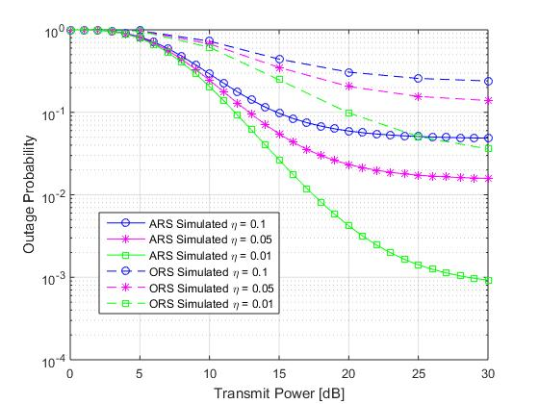

Fig 2. Transmit Power - Outage probability comparison of ARS Scheme and ORS Scheme for M = 1 relays

It shows the effect of different loop interference values a channel possesses on an M = 1 relay system and its comparison with the conventional ORS system. The transmission rate is set at 3 bps/Hz. The outage probability curve matches the result obtained in expression (23). It can be noted at the probability for attenuation of signals to occur is lowest for η = 0.01 and increases for η =0.1 with an increase in the transmission power in case of ARS system. The performance of M = 0.1 ORS system matches that of M = 0.01 ARS system. Hence, self-interference between the relay nodes must be maintained to a minimum in order to achieve greater throughput and lesser outage probability in an ARS system.

The outage probability for various values of transmit power is obtained by retaining the SI factor η at a constant value of 0.05 and carrying out the analyses for M = 1, 2 and 3 relays in Fig 3. The ARS curves obtained are plotted alongside ORS curves to show the optimized performance of the ARS proposed system.

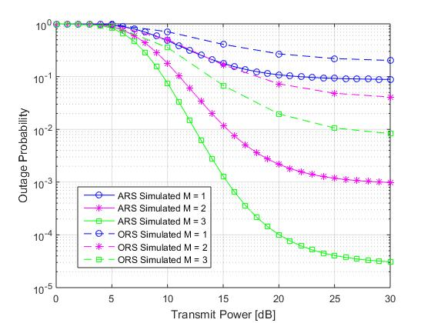

Fig 3. Transmit Power - Outage Probability comparison for ARS Scheme and ORS Scheme for 3η = 0.05

The performance of the proposed system is compared with conventional optimal relay select ORS system. The proposed ARS method achieves the same performance as two relay nodes operating by the ORS method. Thus, the ARS method outperforms the conventional ORS method for full-duplex relay systems.

The outage probability for various values of self-interference is obtained by retaining the SI factor η at a constant value of 0.05 and carrying out the analyses for M = 1, 2 and 3 relays in Fig 4. The ARS curves obtained are plotted alongside ORS curves to show the optimized performance of the ARS proposed system.

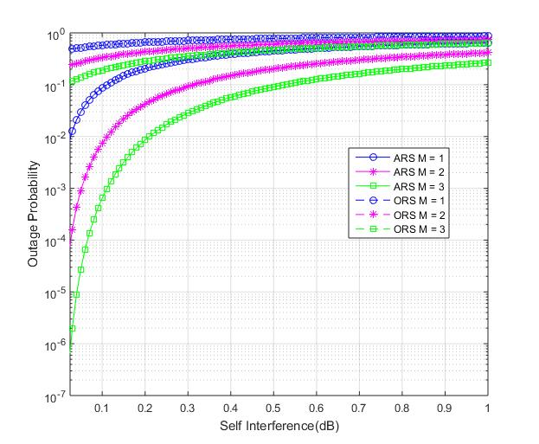

Fig 4. Self-Interference - Outage Probability comparison for ARS Scheme and ORS Scheme η = 0.05

As the self-interference factor increases, the outage probability nearly approaches 0 in case of ARS system. This is unlike the ORS system in which the outage probability approaches 0 and a near complete attenuation of signals occurs. The ARS system with M = 1 relay has the same performance against self-interference as an ORS system with M = 3 relays. Hence, the ARS system is advantages for full duplex communication than ORS system.

The outage probability for various values of rate of transmission is obtained by retaining the SI factor η at a constant value of 0.05 and carrying out the analyses for M = 1, 2 and 3 relays in Fig 5. The ARS curves obtained are plotted alongside ORS curves to show the optimized performance of the ARS proposed system.

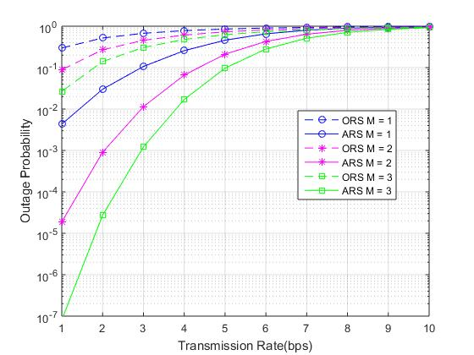

Fig. 5. Transmission Rate - Outage Probability comparison of ARS Scheme and ORS Scheme for η = 0.05

The outage probability of M = 1 ARS system outperforms the outage probability performance of M = 3 ORS system. The outage probability for an ARS system is a small value for lower transmission rate, in comparison to the ORS system. This is a direct indication of added space diversity through joint antenna and relay selection. However, it must be noted that, with an increase in the number of bits transmitted for the constant SI value, the signals reach outage in case of both ARS and ORS system. While outage is reached later in case of ARS M = 3, both ARS and ORS system suffer outage at higher transmission rate values.

The SER for various values of transmit power is obtained by retaining the number of relay M =1 and carrying out the analysis for SI factor η = 0.05, 0.01 and 0.1 in Fig 6.

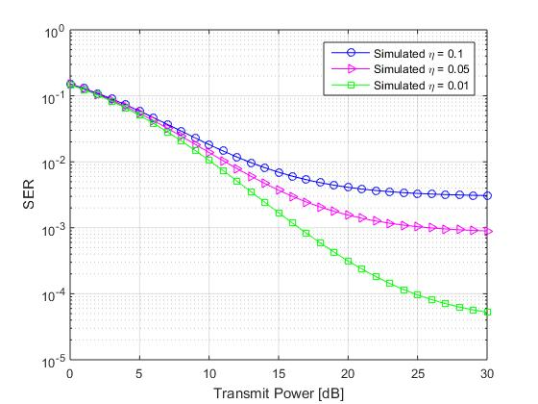

Fig. 6 Transmit Power – SER analysis of ARS Scheme for M =1 relays

Through this analysis, the impact of the loop interference on SER in the single relay system is investigated. SER is lowest when the self-interference factor is lowest. However, as the value of self-interference increases, the system performance lowers and signals are lost to interference. This performance does not falter by a large number and it can be noticed that the SER curve is relatively identical and stable for η = 0.05 and 0.1 values. These values are taken according to real world case scenario and are projected according to what can be expected of a channel.

The SER for various values of transmit power is obtained by retaining the SI factor constant, η = 0.05 and carrying out SER analysis for M =1,2 and 3 relays.

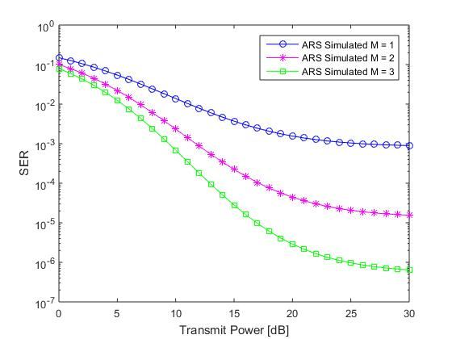

Fig. 7 Transmit Power – SER analysis of ARS Scheme for η = 0.05

The graph shows that a single relay system has the highest SER value in comparison to multiple relay systems. The primary reason for this is because additional relay add directional diversity and allow for a better symbol throughput. Multiple relay systems only provide desirable results when the interference value is relatively moderate. For higher values of interference, the system does not perform as required and a large number of packers are lost due to interference and deep fading. This is the shortcoming of the project and an alternative method for reducing SER for high interference must be devised.

1. **SUMMARY**

In this project, a joint relay and antenna selection scheme was proposed and implemented. This scheme consisted of M relays in multiple FD relay networks and a source and destination node. An antenna selection procedure was explained in detail where, the optimal relay with the best transmitter- receiver configuration was chosen to carry out communication between the source and the destination node. Closed form expressions for CDF, Antenna Selection Method, Outage Probability and SER were derived and the evaluation of their results was achieved. Simulations were obtained for Outage Probability and SER as has been shown in the project demonstration. An analysis of the results has been carried out in the same section through a comparison of the proposed system with a conventional system. Through the implementation of the project, we have achieved additional space diversity at the destination node which has resulted in better performance in comparison to the ORS system. This additional space diversity was achieved in the ARS method because of a tradeoff with SI. A permissible amount of SI was allowed to affect the system at the cost of increasing space diversity through intelligent antenna and relay selection. The system still suffers from the effects of deep fading on the channel link between the relay, source and destination nodes. Outage Probability and SER reach high values as the value of SNR increases and analysis of the system could not be achieved at these values. This arises due to self-interference at the relay node. The performance of the system can be better improved by implementing better self-interference cancellation methods at the relay node in future work.



1. Gong, Feng-Kui, Jian-Kang Zhang, and Jian-Hua Ge. "Distributed concatenated Alamouti codes for two-way relaying networks." Wireless Communications Letters, IEEE 1.3 (2012): 197-200.
2. H. Jin and V. Leung, "Performance analysis of full-duplex relaying employing fiber-connected distributed antennas, " IEEE Trans. Veh. Technol., Jul. 2013.
3. I. Krikidis, H. A. Suraweera, P. J. Smith, and C. Yuen, "Full-duplex relay selection for amplify-And-forward cooperative networks, " IEEE Trans. Wireless Commun., vol. 11, no. 12, pp. 4381-4393, Dec. 2012.
4. M. Zhou, H. Cui, L. Song, and B. Jiao, "Transmit-receive antenna pair selection in full duplex systems, " IEEE Wireless Commun. Lett., pp. 1-4, Nov. 2013.
5. I. S. Gradshteyn and I. M. Ryzhik, Table of integals, series, and products, 5th Edition, Academic Press, 1994

